
Creatively Embracing 21st Century Youth Scholarship and Fundraising Gala
November 20, 2014 at Chateau La Mer, Lindenhurst, New York

©Your Time For Creative Empowerment, Inc. www.yourtime4liny.org
Photography by Anahi DeCanio-Arty Zen Studio

Honoree Cynthia Costanzo-Metzger, Associate Director of Development at Molloy College and George Siberon, the

Executive Director of the Hispanic Civic Association with Kelly Metzger
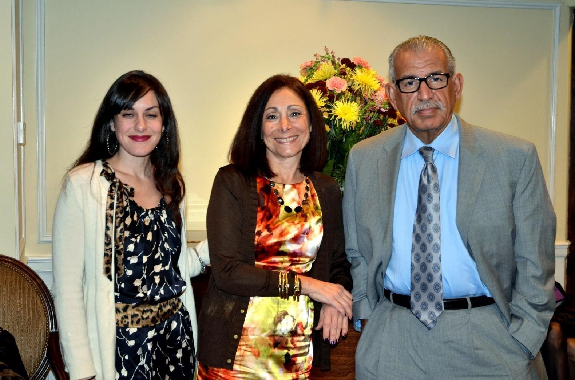

Honoree legislator Carrie Solages, Marie Vincent
and 2013 Honoree Hempstead Village Trustee Don Ryan
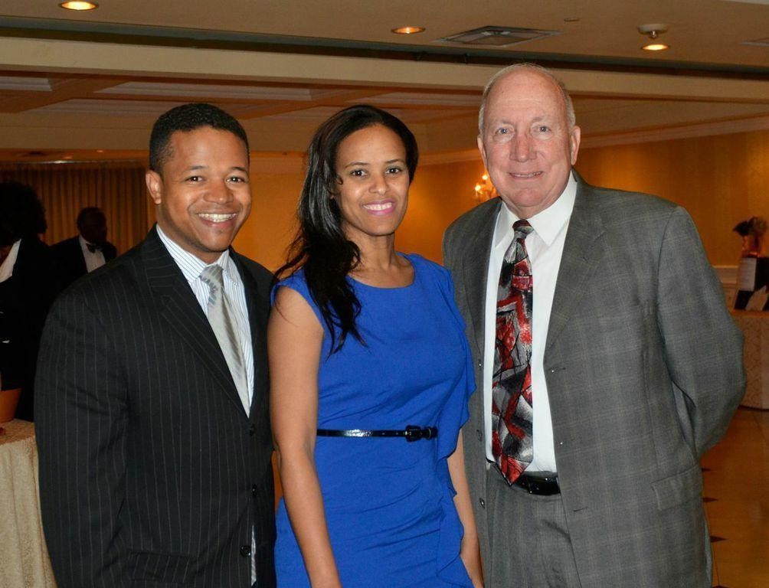

10th grade winner Samantha Uebel of North Babylon High School (right) with Master of Ceremonies Waldo Cabrera
and Founder, Madona Cole-Lacy
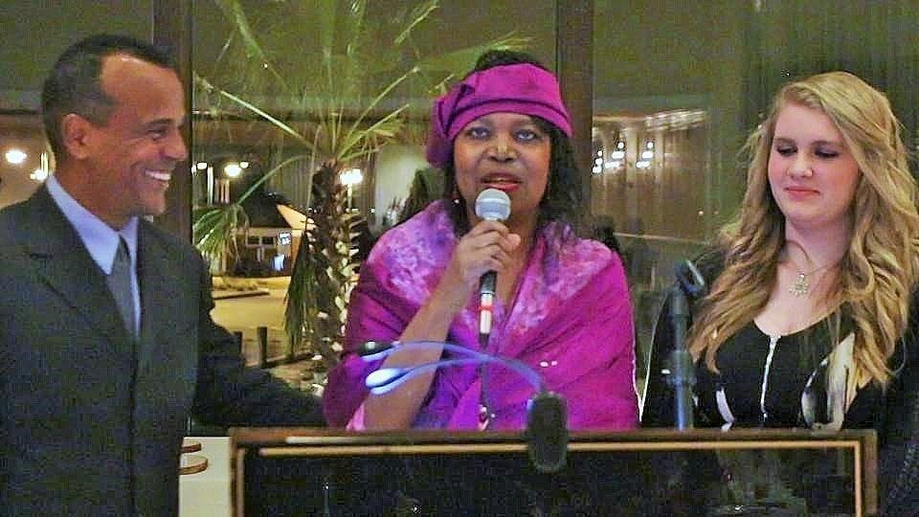

2013 Honoree Margarita Grasing, Executive Director of Hispanic Brotherhood
of Rockville Centre with her Co-Director Marguerite Keller
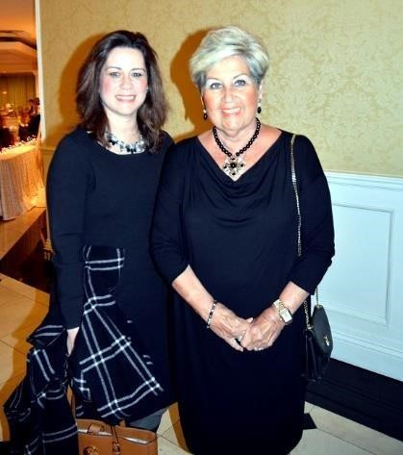

Contestants L to R) Marie Saint-Cyr, Veronica Lane, Kitty Zhen,
Founder Madona Cole-Lacy, Program Director James Lacy, Nailah Garard and sister, Julia Maher, Board Vice-President Madeline Quintyne, Samantha Uebel, Tatiana Woellhof.
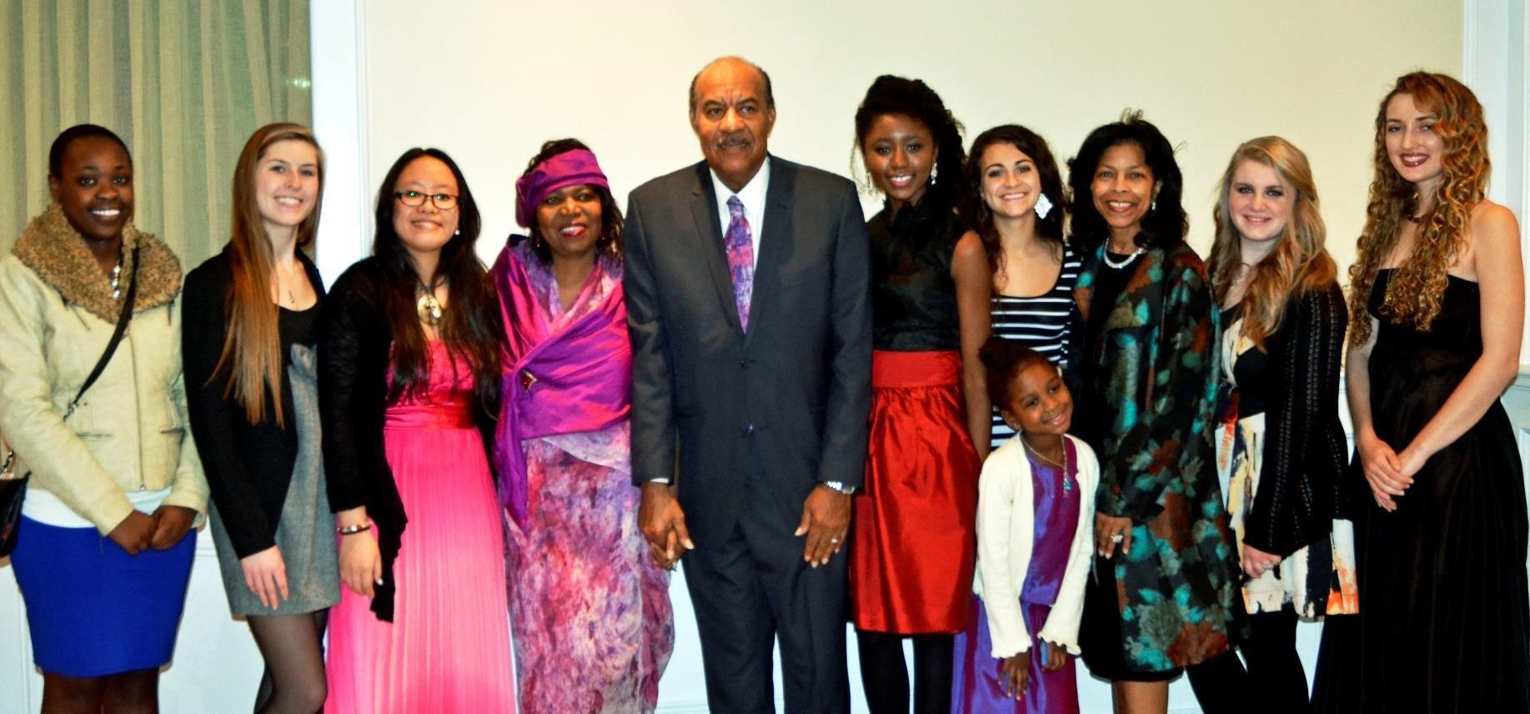

Honoree Councilwoman Jackie Gordon with Your Time

For Creative Empowerment, Inc. Founder Madona Cole-Lacy
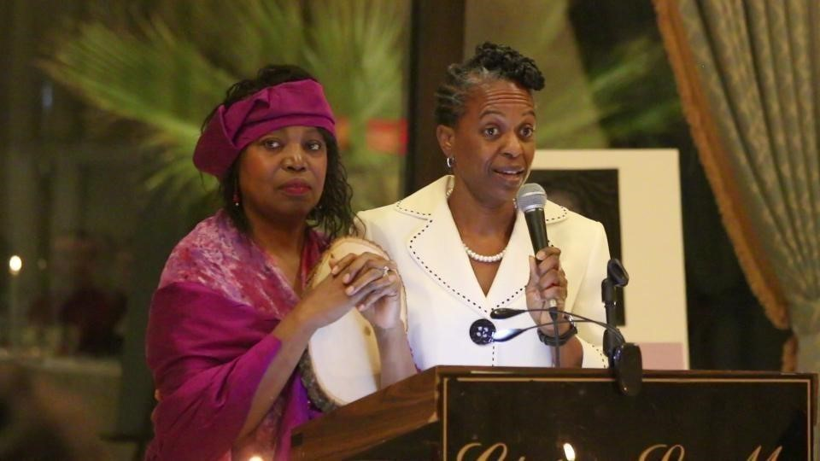

Honoree George Siberon with Madona Cole-Lacy
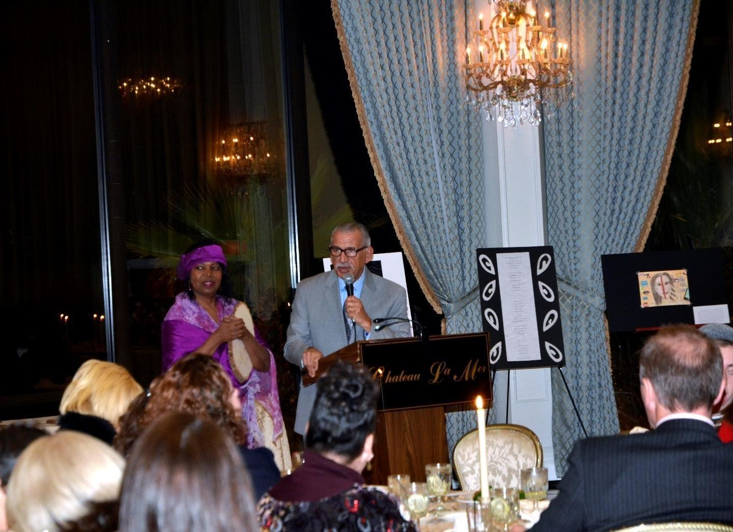

Honoree Patricia Francis Co-Organizer and recent past president. The Sisters of the Arts, Nassau/ Suffolk/Queens Chapter, The Society Incorporated, and Member of National Executive Board
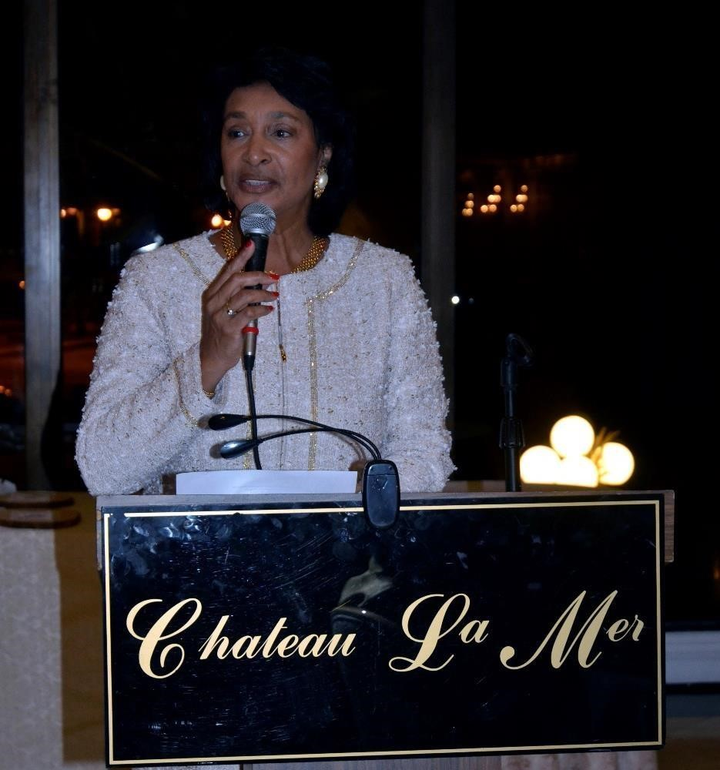

Guests at Creatively Embracing 21st Century Youth Gala
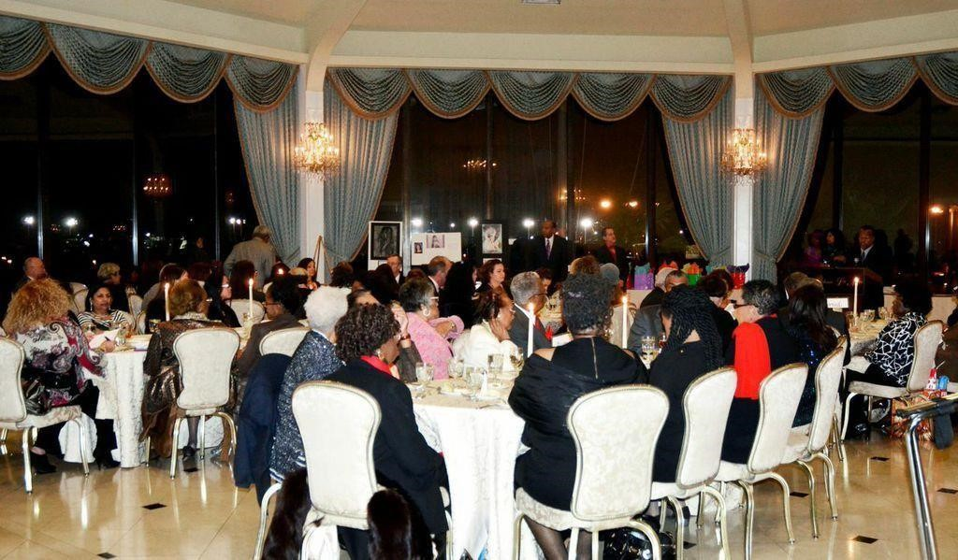

Scholarship Winner Julia Maher of Farmingdale High School with her creative expression, 'Slipping away from Sanity' also known as 'Paranoia'
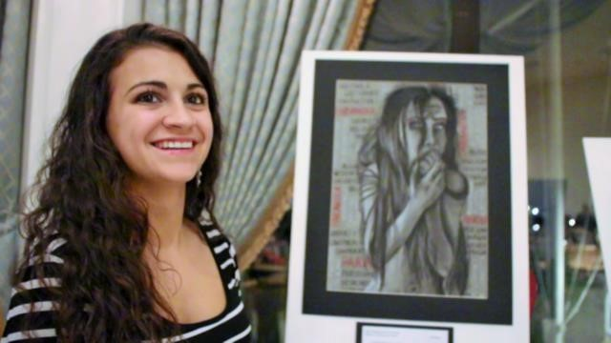

Representing Honoree Dr. Deborah Wortham, Superintendent of Roosevelt Union Free School District-Emily Moore, Dr. Abah Bhatnager, Diane Battle, Curtis Ramdawar and Mariana Crespo
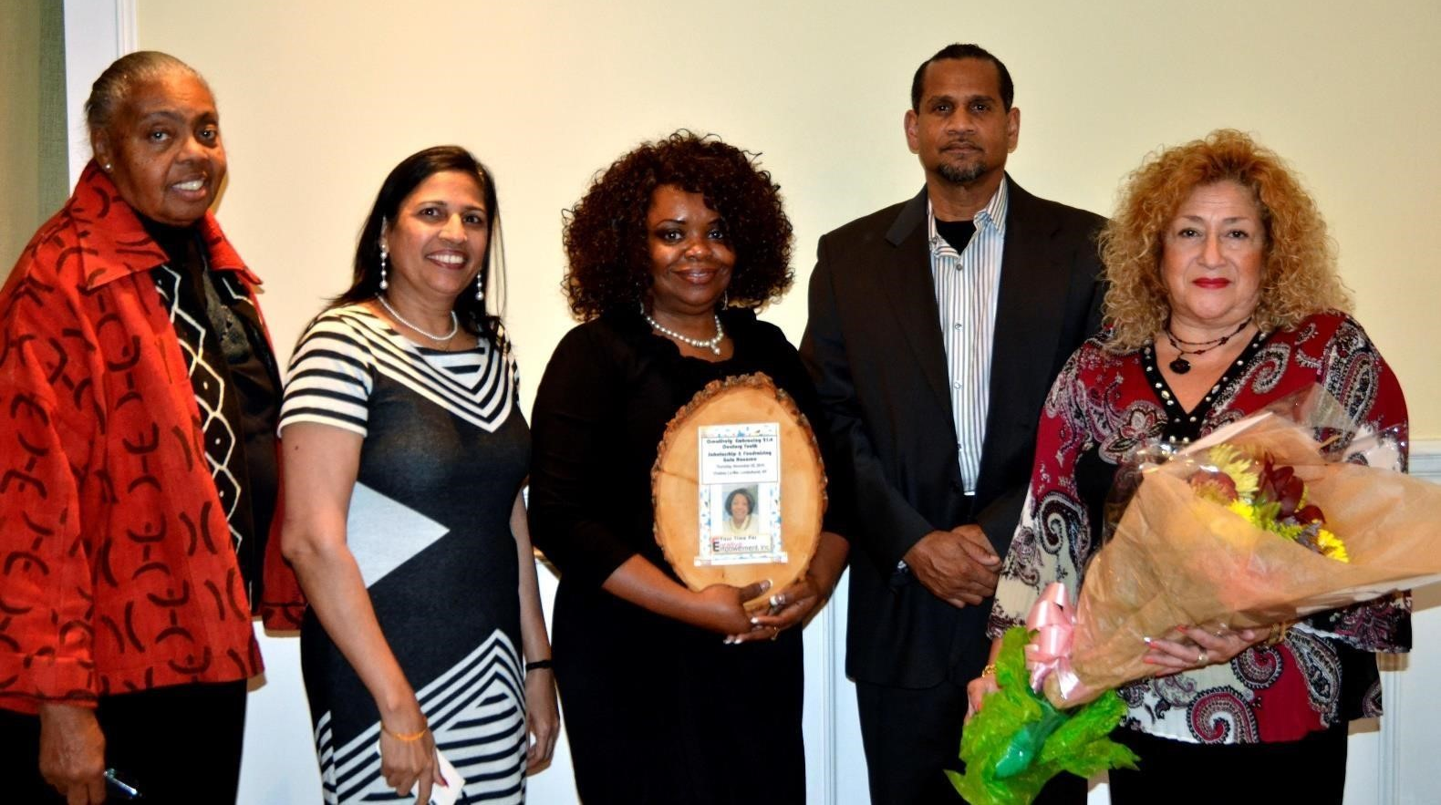

College Scholarship Winner Nailah Garard of Half Hollow Hills High School East shares her thoughts behind her creative expression 'Trapped'
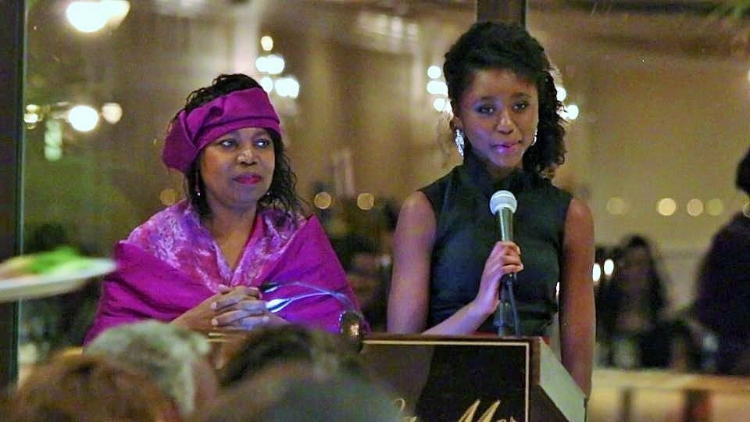

Honoree Theresa Statz-Smith, Executive Director of Long Island Arts Alliance with CEO of Your Time For Creative Empowerment, Inc
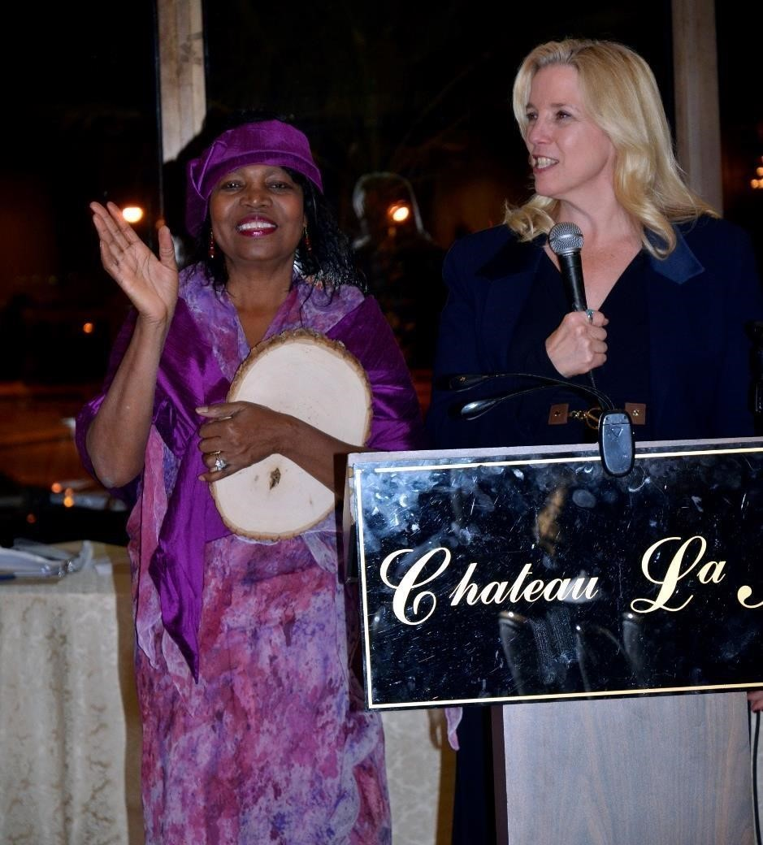

Honoree Mel Jackson, Executive Director of Leadership Training Institute at the podium with Madona Cole-Lacy
